L2: Receivables Management->L3: Accounts Receivable Ledger Management ->L4: Manage Cash Applications->
L5: Process Direct Debit Payment
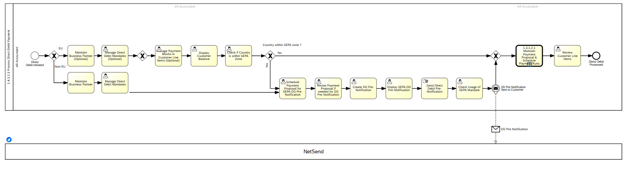
L5: Process Lockbox
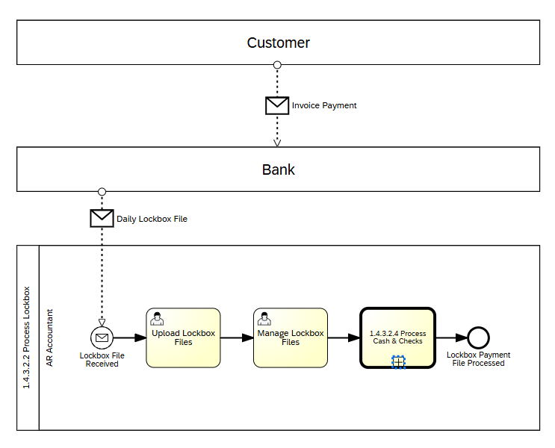

L5: Process ACH / EFT / Wire Payment
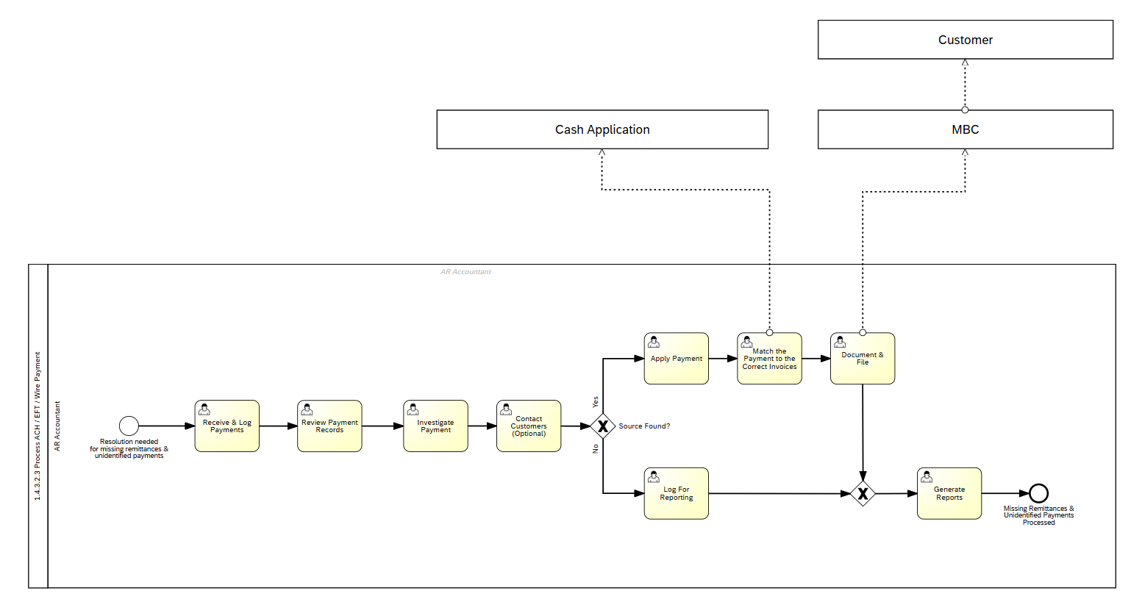
L5: Process Cash and Checks
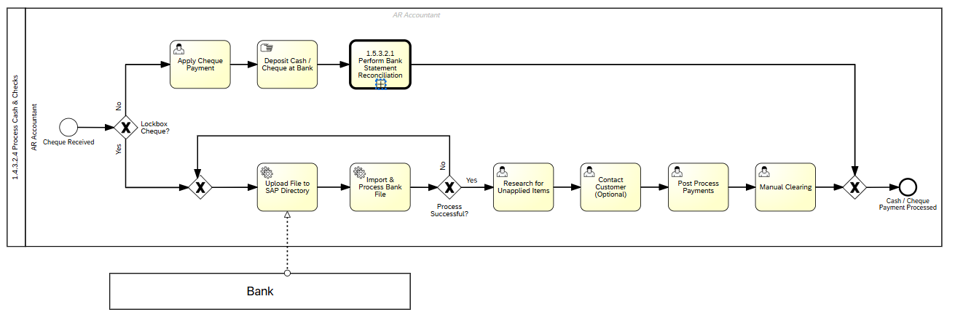
L5: Process Credit / Payment Card
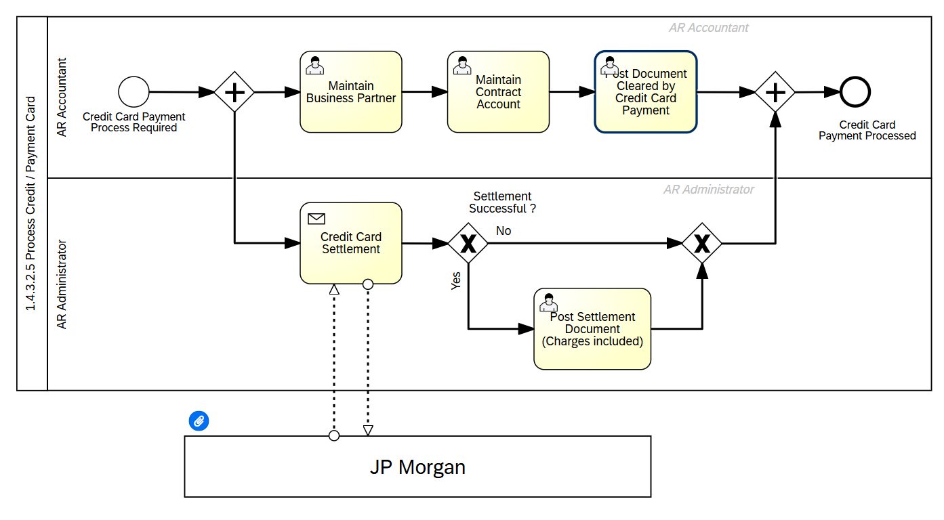
L5: Process Customer Down Payments
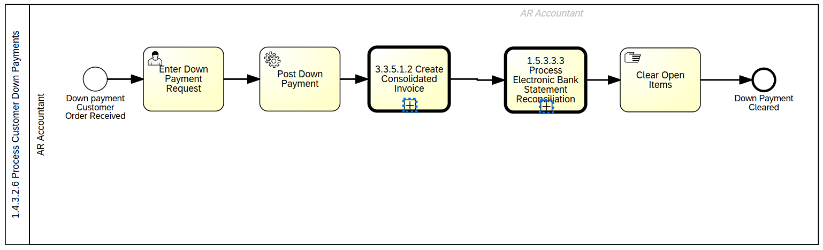
L5: Execute Bad Debt Reserves & Allowances
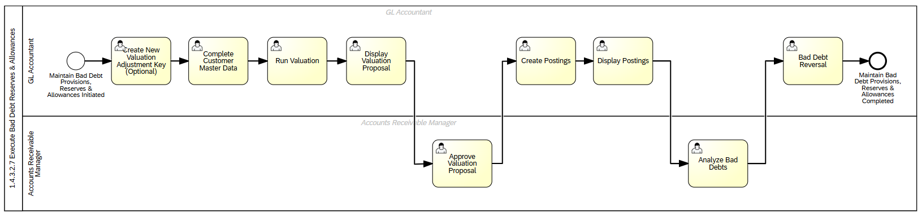
L5: Execute DTC Payment Reconciliation
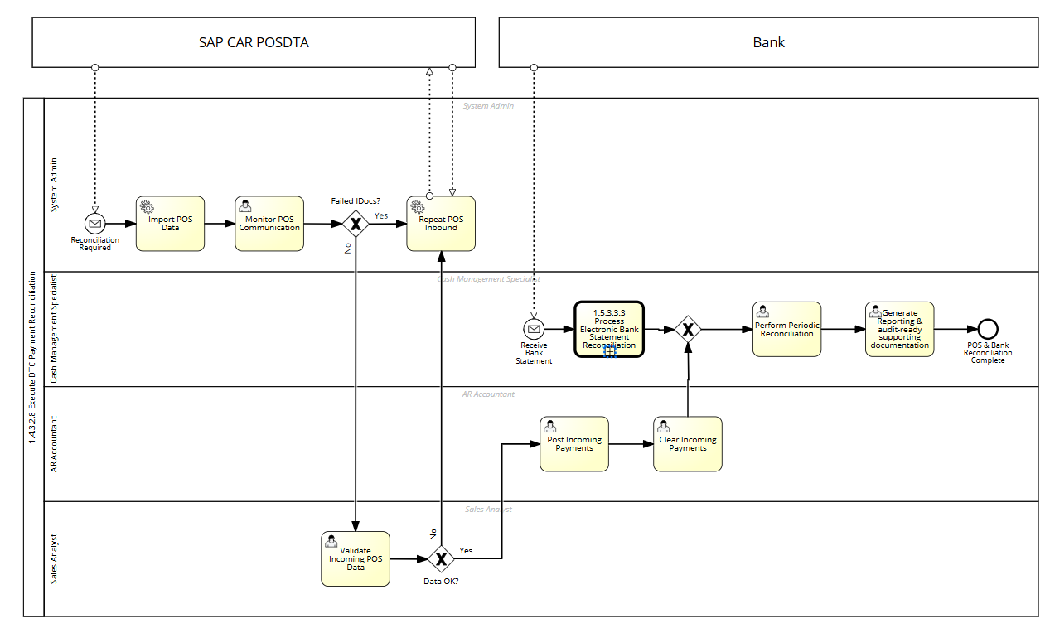

L2: Receivables Management->L3: Customer Inquiry, Dispute & Deductions Management->L4: Receive & Analyze Inquiries, Disputes & Deductions->
L5: Dispute Case Opening
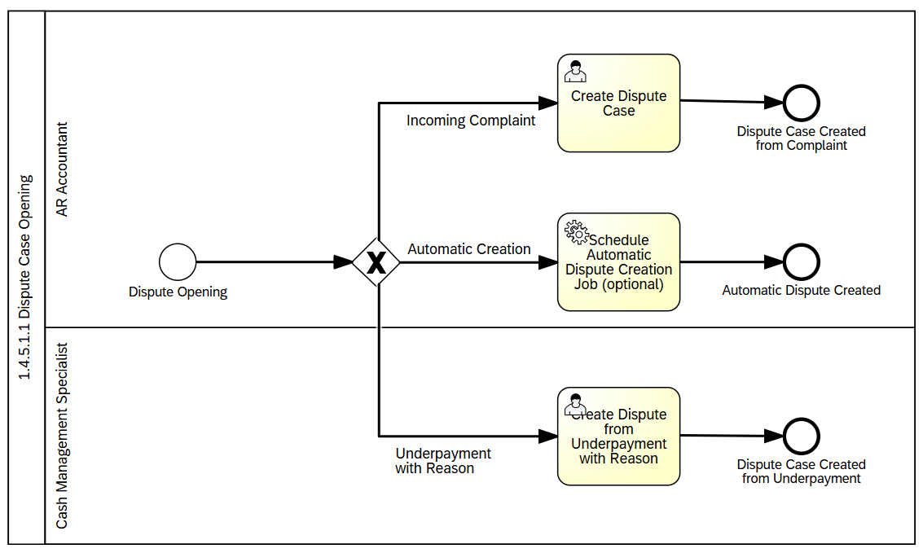
L5:Dispute Case Mgt. activities
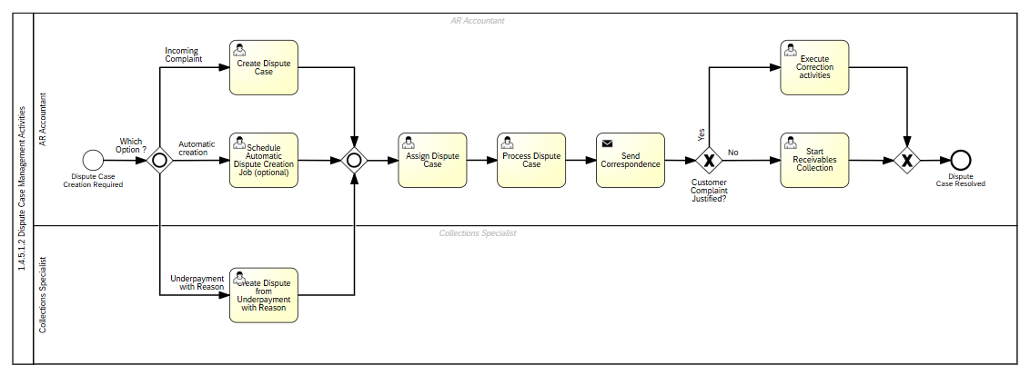

L2: Receivables Management->L3: Customer Inquiry, Dispute & Deductions Management->L4: Customer Dispute Performance/
Reporting & Analytics->
L5:Review Dispute mgt. Performance & KPIs
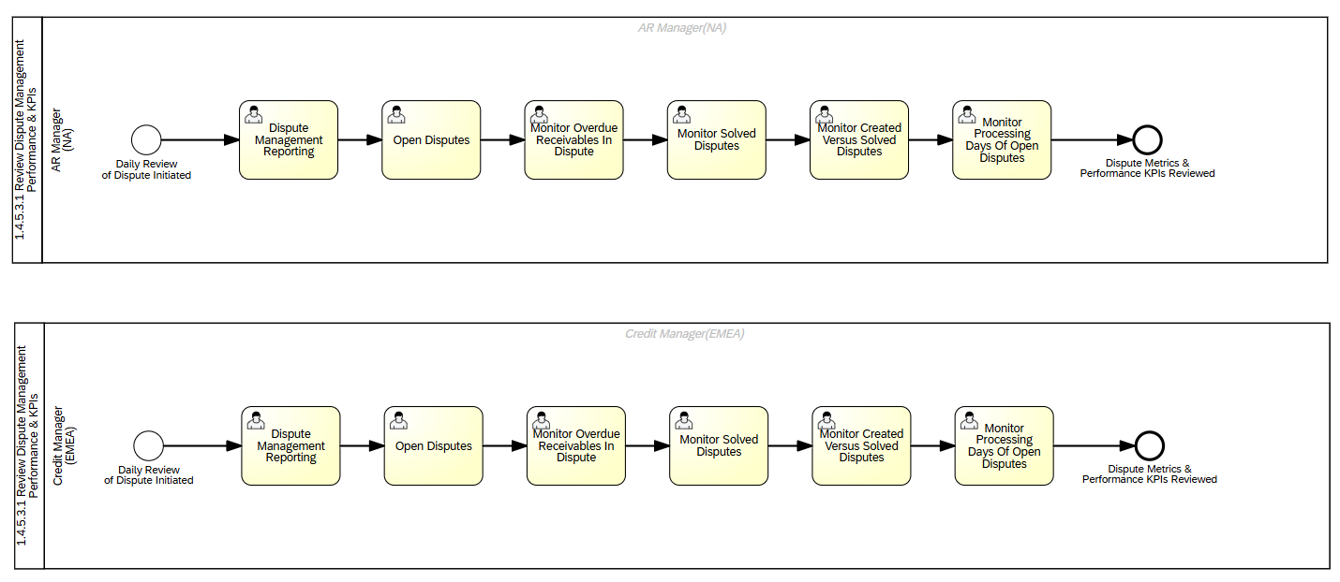

L2: Receivables Management->L3: Revenue Assurance Control Management->L4: Monitor Confirmed Revenue Streams

Identify Revenue Leakage Points

Perform Corrective & Preventive actions

Revenue Assurance Performance/KPI Reporting & Analytics
->

